### Cart based components

### Create Cart

**Use Case Name: Create Cart**

**Author Name: Sajjad Patel, Soutrik, Michael**

**Applicable Business Rule:**

* Customer creates a purchase cart

**Use Case Preconditions:**

- Customer must be signed in to the system

- Customer must not have a cart already in progress

**Use Case Successful Post Conditions:**

* A cart is created with products of the customer's choice

**Main Flow:**

1. Customer chooses items from the catalogue
2. Customer creates a cart based off the chosen items
3. System creates cart

**Alternative Flows:**

1. Item is currently not in stock
   1. System displays current stock of item
   2. Customer updates their cart to update based off the current stock
   3. Customer clicks update
   4. System Creates Cart

A: Test Case Summary

|  |  |  |
| --- | --- | --- |
| **Scenario Name** | | **Scenario Description** |
| Main: Cart created successfully | | User successfully creates the cart |
| Alt: Item is out of stock | The currently selected item is not in stock | |
| Alt: Customer updates cart | Customer chooses to update their cart with different items | |

B: Test Case Details

|  |  |  |  |  |
| --- | --- | --- | --- | --- |
| **Test Case** | **Scenario** | **Data Values/ Conditions being tested** | | **Expected Result** |
|  | Main: Cart Successfully Created | Item is currently in stock. Cart is able to be created | | Stock for the item is greater than 0. Item is added to cart and customer is redirected to checkout |
|  | Alt: Item is out of stock | The item is currently not in stock. The customer is unable to proceed to checkout with current order. | Error message: “Item is not in stock”. Alternative options are displayed. | |
|  | Alt: Customer updates cart | Customer chooses to update their cart with items that are currently in stock | System checks to see whether items are in stock. Displays option to proceed to checkout. | |

### Update Cart

**Use Case Name: Update Cart**

**Author Name: Sajjad Patel, Soutrik, Michael**

**Applicable Business Rule:**

* Customer wants to update their cart

**Use Case Preconditions:**

- Customer must be signed in

- Customer must have a cart already created

**Use Case Successful Post Conditions:**

* Cart is successfully updated

**Main Flow:**

1. Customer clicks cart
2. System retrieves customers cart
3. Customer updates the cart by adding or removing products
4. Customer clicks update
5. System recreates updated cart

**Alternative Flows:**

1. Item is currently not in stock
   1. System displays current stock of item
   2. Customer updates their cart to update based off the current stock
   3. System Creates Cart
2. A: Test Case Summary

|  |  |  |
| --- | --- | --- |
| **Scenario Name** | | **Scenario Description** |
| Main: Cart updated successfully | | User successfully creates the cart |
| Alt: Customer updates cart | Customer chooses to update their cart with different items based off items in stock | |

B: Test Case Details

|  |  |  |  |  |
| --- | --- | --- | --- | --- |
| **Test Case** | **Scenario** | **Data Values/ Conditions being tested** | | **Expected Result** |
|  | Main: Cart Successfully Created | Item is currently in stock. Cart is able to be created | | Stock for the item is greater than 0. Item is added to cart and customer is redirected to checkout. |
|  | Alt: Customer updates cart | Customer chooses to update their cart with items that are currently in stock | System checks to see whether items are in stock. Displays option to proceed to checkout. | |

### Delete Cart

**Use Case Name: Delete Cart**

**Author Name: Sajjad Patel, Soutrik, Michael**

**Applicable Business Rule:**

* Customer wants to delete cart

**Use Case Preconditions:**

- Customer must have a cart already created

**Use Case Successful Post Conditions:**

* Cart is successfully deleted

**Main Flow:**

1. Customer Clicks on Cart
2. System retrieves customer`s cart
3. Customer clicks delete cart
4. System asks for confirmation
5. System removes cart from system

**Alternative Flows:**

1. Customer decides to not delete cart
   1. Customer clicks no for confirmation
   2. System redisplays cart with all chosen products
2. A: Test Case Summary

|  |  |  |
| --- | --- | --- |
| **Scenario Name** | | **Scenario Description** |
| Main: Cart is successfully deleted | | User deletes created cart |
| Alt: User decides to not delete cart | The user created cart is not deleted | |

B: Test Case Details

|  |  |  |  |  |
| --- | --- | --- | --- | --- |
| **Test Case** | **Scenario** | **Data Values/ Conditions being tested** | | **Expected Result** |
|  | Main: Cart Successfully Deleted | The cart is currently not empty. | | The user selects the option to delete cart. Confirmation window appears and user chooses confirm. Cart is emptied. |
|  | Alt: User decides to not delete cart | The cart is currently not empty. | The user selects the option to delete cart. Confirmation window appears and user chooses No. Cart is not deleted. | |

### Retrieve Cart

**Use Case Name: Retrieve Cart**

**Author Name: Sajjad Patel, Soutrik, Michael**

**Applicable Business Rule:**

* Customer wants to review their current cart

**Use Case Preconditions:**

- Customer must be signed in

- Customer must have a cart already created

**Use Case Successful Post Conditions:**

* Customer retrieves previously created carts

**Main Flow:**

1. Customer clicks on cart
2. System displays list of carts created
3. Customer can choose from current cart or previously created carts
4. Customer chooses previously created carts
5. Customer reviews information

**Alternative Flows:**

1. Customer Chooses to update current cart
   1. Customer clicks on current cart
   2. Customer updates information on cart
   3. Customer clicks update
   4. System saves cart information
2. Customer chooses to delete current cart
   1. System clicks on current cart
   2. Customer chooses to delete current cart
   3. System displays confirmation message
   4. Customer clicks confirms
   5. System deletes current cart

|  |  |  |
| --- | --- | --- |
| **Scenario Name** | | **Scenario Description** |
| Main: Customer clicks on cart history | | User selects the option cart history. System returns a list of all carts created on account. |
| Main: Customer chooses previously created cart | Customer chooses a cart from the list displayed. | |
| Main: Customer reviews information | Customer reviews the information on the cart. If the cart is current the customer has the option of adding or removing items from cart. | |
| Alt: Customer Updates cart | Customer chooses to add or remove items from the current cart selected | |
| Alt: Customer Deletes current cart | Customer chooses to delete the current cart | |

B: Test Case Details

|  |  |  |  |  |
| --- | --- | --- | --- | --- |
| **Test Case** | **Scenario** | **Data Values/ Conditions being tested** | | **Expected Result** |
|  | Main: Customer clicks on cart history | At least one cart has to have been created. | | Cart history displayed with all current and past user carts. |
|  | Main: Customer chooses previously created cart | At least one cart has to have been previously created. | Specific cart information displayed. | |
|  | Main: Customer reviews information | At least one cart has been created previously. Customer has selected one of the carts from the list. | System returns information for the selected cart. Customer reviews information for order. Update or delete cart options displayed. | |
|  | Alt: Customer updates cart | Cart has to be current and not processed. | System displays information for order. Customer chooses to add or remove items from cart. Option to save or check out are displayed. | |
|  | Alt: Customer deletes cart | Cart has to be current and not processed. | System displays information for order Customer chooses to delete cart. Confirmation option is displayed. Customer chooses “Yes”. Cart is deleted. | |

Activity Diagrams for Cart

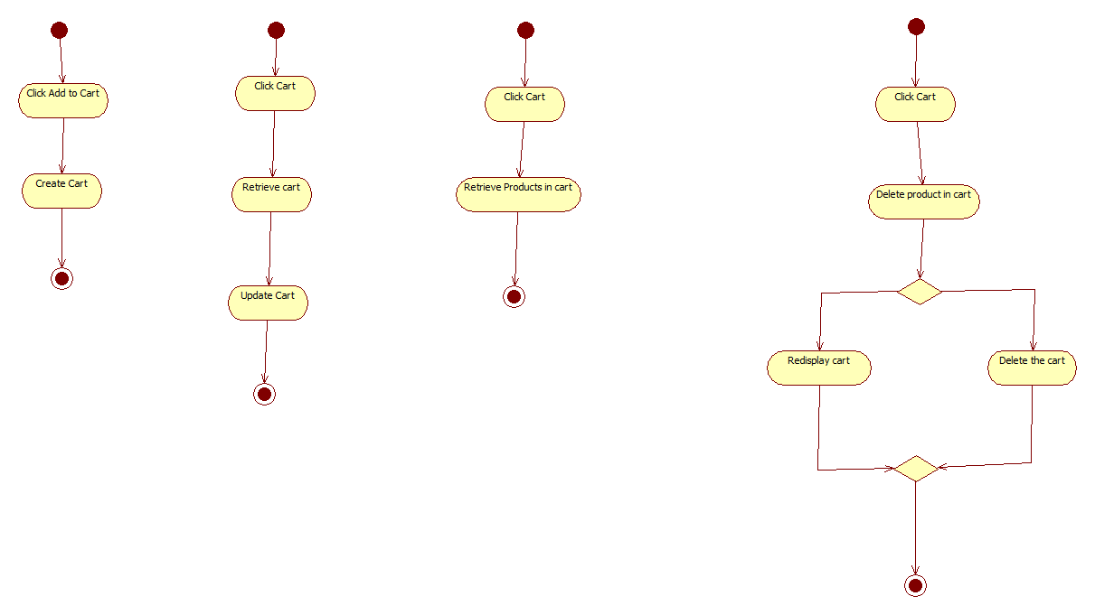

### Account based components

### Register Account

**Use Case Name: Register Account**

**Author Name: Sajjad Patel, Soutrik Barua, Michael Vuong**

**Applicable Business Rule:**

* Customer can register his/her account on the website only using e-mail.

**Use Case Preconditions:**

Person must have a valid e-mail address to go further on with the registration.

**Use Case Successful Post Conditions:**

A new account is made.

**Main Flow:**

1. Customer clicks on register account
2. System retrieves registration form
3. Customer fills out their basic information,address,e-mail etc.
4. Customer fills out the form and clicks register
5. System updates registration

**Alternative Flows:**

1. Wrong input field provided
   1. System refreshes registration page with correct information pre loaded
   2. User types in correct information in the incorrect fields
   3. System updates registration

|  |  |  |
| --- | --- | --- |
| 1. **Scenario Name** | | **Scenario Description** |
| Main: Customer successfully registers account | | Customer registers a new account |
| Alt: Wrong input field provided | Customer enters incorrect information | |

B: Test Case Details

|  |  |  |  |  |
| --- | --- | --- | --- | --- |
| **Test Case** | **Scenario** | **Data Values/ Conditions being tested** | | **Expected Result** |
|  | Main: Customer successfully registers account | Customer enters correct information for the form fields | | New account form displayed; form is submitted; database updated with new account. |
|  | Alt: Wrong input field provided | Customer enters incorrect information into the form fields | Customer chooses to create a new account. System returns a form, customer fills out form incorrectly. Error message, please fill out form correctly. Customer chooses to close form and new account is not created. | |

### Delete User

**Use Case Name: Delete Account**

**Author Name: Sajjad Patel, Soutrik, Michael**

**Applicable Business Rule:**

* Customer can delete his/her account on the website only if registered

**Use Case Preconditions:**

Person must have a valid account

**Use Case Successful Post Conditions:**

An account is deleted.

**Main Flow:**

1)Customer clicks on delete account

2)System retrieves delete form

3)Customer fills out the form and clicks delete account

4)System updates user base.

**Alternative Flows:**

1. Wrong input field provided
   1. System refreshes delete page with correct information pre loaded
   2. User types in correct information in the incorrect fields
   3. System updates user base

|  |  |  |
| --- | --- | --- |
| **Scenario Name** | | **Scenario Description** |
| Main: Customer deletes account | | Customer chooses to delete account |
| Alt: Customer does not delete account | Customer chooses to not delete account | |

B: Test Case Details

|  |  |  |  |  |
| --- | --- | --- | --- | --- |
| **Test Case** | **Scenario** | **Data Values/ Conditions being tested** | | **Expected Result** |
|  | Main: Customer deletes account | Customer must have a valid account and be signed into it. | | Account information displayed; deletion confirmation prompt displayed; once confirmed database is updated. |
|  | Alt: Customer decides to not delete account | Customer must have a valid account and be signed into it. | The user selects the option to delete account. Confirmation window appears and user chooses No. The account is not deleted. | |

### Update User

**Use Case Name: Update Account**

**Author Name: Sajjad Patel, Soutrik Barua, Michael Voung**

**Applicable Business Rule:**

* Customer can update his/her account on the website with a valid account.

**Use Case Preconditions:**

Person must have a valid account

**Use Case Successful Post Conditions:**

An account is updated.

**Main Flow:**

1)Customer clicks on update account

2)System retrieves account information form

3)Customer fills out the fields to be updated on the form and clicks update account

4)System updates user base.

**Alternative Flows:**

1. Wrong input field provided
   1. System refreshes delete page with correct information pre loaded
   2. User types in correct information in the incorrect fields
   3. System updates user base

|  |  |  |
| --- | --- | --- |
| **Scenario Name** | | **Scenario Description** |
| Main: Customer updates account | | User updates account |
| Alt: User chooses to not update account | Account remains unchanged | |

B: Test Case Details

|  |  |  |  |  |
| --- | --- | --- | --- | --- |
| **Test Case** | **Scenario** | **Data Values/ Conditions being tested** | | **Expected Result** |
|  | Main: Customer updates account | Account is valid and user is currently signed in. | | Account information displayed; form is filled to change account information; confirmation prompt; new account is saved to database. |
|  | Alt: User chooses to not update account | Account is valid and user is currently signed in. | The user selects the option to update account. System returns form for account update. User does not update information. Account does not update. | |

Activity Diagrams for account



**Use Case Name: Delete Order**

**Author Name: Sajjad Patel, Soutrick, Michael**

**Applicable Business Rule:**

* Y.R Distribution: Wants to be able to delete order

**Use Case Preconditions:**

Person that wants to make these changes must be signed in and must be a manager or an employee depending on the changes being made.

**Use Case Successful Post Conditions:**

* Order must be deleted

**Main Flow:**

1. Employee/Manager Clicks on Orders
2. System retrieves all the Orders
3. Employee/Manager Clicks Delete Next to Order to be deleted
4. System Deletes Order

**Alternative Flows:**

1. Sign in wrong
   1. System opens password recovery page
   2. User types in email address
   3. System emails customer password

|  |  |  |
| --- | --- | --- |
| **Scenario Name** | | **Scenario Description** |
| Main: Employee or manager deletes order | | Employee or manager chooses to delete order |
| Alt: Incorrect log in to employee or manager account | Password recovery form is displayed. Employee successfully resets password. | |

B: Test Case Details

|  |  |  |  |  |
| --- | --- | --- | --- | --- |
| **Test Case** | **Scenario** | **Data Values/ Conditions being tested** | | **Expected Result** |
|  | Main: Employee or manager deletes order | Either an employee or manager is currently signed in. | | System returns a list of orders; order is selected and employee is prompted for deletion; deletion confirmed; database is updated. |
|  | Alt: Employee or Manager inputs incorrect login information | Employee or manager forgets login information. | System displays password recovery form; Employee fills out form; system returns password reset form; Employee confirms and changes password. | |

**Use Case Name: Retrieve Order**

**Author Name: Sajjad Patel, Soutrick, Michael**

**Applicable Business Rule:**

* Y.R Distribution: Wants to be able to retrieve orders

**Use Case Preconditions:**

Person that wants to make these changes must be signed in and must be a manager or an employee depending on the changes being made.

**Use Case Successful Post Conditions:**

* Order is retrieved

**Main Flow:**

1. Employee/Manager Clicks on orders
2. System retrieves all the orders

**Alternative Flows:**

1. Sign in wrong
   1. System opens password recovery page
   2. User types in email address
   3. System emails customer password

|  |  |  |
| --- | --- | --- |
| **Scenario Name** | | **Scenario Description** |
| Main: Employee or manager retrieves a list of orders | | Employee or manager receives a list of current orders |
| Alt: Incorrect log in to employee or manager account | Password recovery form is displayed. Employee successfully resets password. | |

B: Test Case Details

|  |  |  |  |  |
| --- | --- | --- | --- | --- |
| **Test Case** | **Scenario** | **Data Values/ Conditions being tested** | | **Expected Result** |
|  | Main: Employee or manager receives a list of orders | Either an employee or manager is currently signed in. | | System displays order information. |
|  | Alt: Employee or Manager inputs incorrect login information | Employee or manager forgets login information. | System displays password recovery form; Employee fills out form; system returns password reset form; Employee confirms and changes password. | |

**Use Case Name: Update Order Status**

**Author Name: Sajjad Patel, Soutrick, Michael**

**Applicable Business Rule:**

* Y.R Distribution: Wants to be able to update order

**Use Case Preconditions:**

Person that wants to make these changes must be signed in and must be a manager or an employee depending on the changes being made.

**Use Case Successful Post Conditions:**

* Order status is updated

**Main Flow:**

1. Employee/Manager Clicks on Orders
2. System retrieves all the Orders
3. Employee/Manager Clicks Update Next to order to be updated
4. System retrieves update page
5. Employee/Manager clicks on dropdown menu and click Processing or Shipped
6. System updates Order Status

**Alternative Flows:**

1. Sign in wrong
   1. System opens password recovery page
   2. User types in email address
   3. System emails customer password

|  |  |  |
| --- | --- | --- |
| **Scenario Name** | | **Scenario Description** |
| Main: Employee or manager updates order information | | Employee or manager receives a list of current orders and updates the information |
| Alt: Incorrect log in to employee or manager account | Password recovery form is displayed. Employee successfully resets password. | |

B: Test Case Details

|  |  |  |  |  |
| --- | --- | --- | --- | --- |
| **Test Case** | **Scenario** | **Data Values/ Conditions being tested** | | **Expected Result** |
|  | Main: Employee or manager updates order information | Either an employee or manager is currently signed in. | | System displays order information; specific order information displayed; order becomes either processed or shipped; database is updated. |
|  | Alt: Employee or Manager inputs incorrect login information | Employee or manager forgets login information. | System displays password recovery form; Employee fills out form; system returns password reset form; Employee confirms and changes password. | |

ACTIVITY DIAGRAM

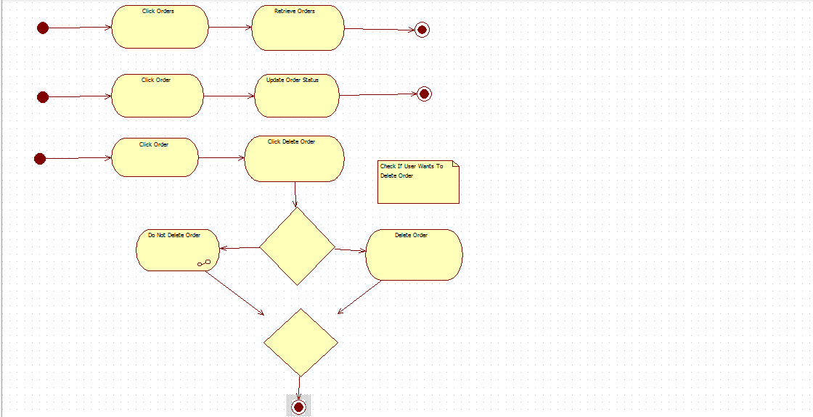

**Use Case Name: Create Product**

**Author Name: Sajjad Patel, Soutrick, Michael**

**Applicable Business Rule:**

* Y.R Distribution: Wants to be able to create products

**Use Case Preconditions:**

Person that wants to make these changes must be signed in and must be a manager or an employee depending on the changes being made.

**Use Case Successful Post Conditions:**

* Product must be created

**Main Flow:**

1. Employee/Manager Clicks on Products
2. System retrieves all the products
3. Employee/Manager Clicks Create Product
4. System retrieved create page for product
5. Employee/Manager Fills in information and clicks Create
6. System Creates Product

**Alternative Flows:**

1. Sign in wrong
   1. System opens password recovery page
   2. User types in email address
   3. System emails customer password
2. Invalid Information
   1. System redisplays Page to User
   2. User fixes the areas that have a red asterisk and clicks Create
   3. System Creates Product

|  |  |  |
| --- | --- | --- |
| **Scenario Name** | | **Scenario Description** |
| Main: Employee or manager adds a new product to the catalog | | Employee or manager receives a list of current orders |
| Alt: Incorrect log in to employee or manager account | Password recovery form is displayed. Employee successfully resets password. | |
| Alt: Invalid information entered | Invalid information for new product is entered | |

B: Test Case Details

|  |  |  |  |  |
| --- | --- | --- | --- | --- |
| **Test Case** | **Scenario** | **Data Values/ Conditions being tested** | | **Expected Result** |
|  | Main: Employee or manager adds a new product to the catalog | Either an employee or manager is currently signed in. | | System displays new product form; confirmation prompt that information is correct; new product is added to database. |
|  | Alt: Employee or Manager inputs incorrect login information | Employee or manager forgets login information. | System displays password recovery form; Employee fills out form; system returns password reset form; Employee confirms and changes password. | |
|  | Alt: Invalid information entered | Employee or manager enters incorrect information in new product form | Redisplays form with corrections needed to be made; form is resubmitted with correct information; new product is added to database | |

**Use Case Name: Delete Product**

**Author Name: Sajjad Patel, Soutrick, Michael**

**Applicable Business Rule:**

* Y.R Distribution: Wants to be able to delete products

**Use Case Preconditions:**

Person that wants to make these changes must be signed in and must be a manager or an employee depending on the changes being made.

**Use Case Successful Post Conditions:**

* Product must be deleted

**Main Flow:**

1. Employee/Manager Clicks on Products
2. System retrieves all the products
3. Employee/Manager Clicks Delete Next to Product to be deleted
4. System Deletes Product

**Alternative Flows:**

1. Sign in wrong
   1. System opens password recovery page
   2. User types in email address
   3. System emails customer password

|  |  |  |
| --- | --- | --- |
| **Scenario Name** | | **Scenario Description** |
| Main: Employee or manager deletes a product from the catalog | | Employee or manager deletes an item from the catalog |
| Alt: Incorrect log in to employee or manager account | Password recovery form is displayed. Employee successfully resets password. | |

B: Test Case Details

|  |  |  |  |  |
| --- | --- | --- | --- | --- |
| **Test Case** | **Scenario** | **Data Values/ Conditions being tested** | | **Expected Result** |
|  | Main: Employee or manager deletes a product | Either an employee or manager is currently signed in. Product must be existing in the catalog. | | System displays product list; specific product information displayed; confirmation for deletion prompt; database is saved. |
|  | Alt: Employee or Manager inputs incorrect login information | Employee or manager forgets login information. | System displays password recovery form; Employee fills out form; system returns password reset form; Employee confirms and changes password. | |

**Use Case Name: Retrieve Product**

**Author Name: Sajjad Patel, Soutrick, Michael**

**Applicable Business Rule:**

* Y.R Distribution: Wants to be able to Retrieve products

**Use Case Preconditions:**

Person that wants to make these changes must be signed in and must be a manager or an employee depending on the changes being made.

**Use Case Successful Post Conditions:**

* Product must be retrieved

**Main Flow:**

1. Employee/Manager Clicks on Products
2. System retrieves all the products

**Alternative Flows:**

1. Sign in wrong
   1. System opens password recovery page
   2. User types in email address
   3. System emails customer password

|  |  |  |
| --- | --- | --- |
| 1. **Scenario Name** | | **Scenario Description** |
| Main: Employee or manager retrieves a list of all products | | Employee or manager receives a list of current products |
| Alt: Incorrect log in to employee or manager account | Password recovery form is displayed. Employee successfully resets password. | |

B: Test Case Details

|  |  |  |  |  |
| --- | --- | --- | --- | --- |
| **Test Case** | **Scenario** | **Data Values/ Conditions being tested** | | **Expected Result** |
|  | Main: Employee or manager receives a list of products | Either an employee or manager is currently signed in. | | System displays product list. |
|  | Alt: Employee or Manager inputs incorrect login information | Employee or manager forgets login information. | System displays password recovery form; Employee fills out form; system returns password reset form; Employee confirms and changes password. | |

**Use Case Name: Update Product**

**Author Name: Sajjad Patel, Soutrick, Michael**

**Applicable Business Rule:**

* Y.R Distribution: Wants to be able to Update Product

**Use Case Preconditions:**

Person that wants to make these changes must be signed in and must be a manager or an employee depending on the changes being made.

**Use Case Successful Post Conditions:**

* Product must be Updated

**Main Flow:**

1. Employee/Manager Clicks on Products
2. System retrieves all the products
3. Employee/Manager Clicks Edit Next to Product to be Edited
4. System Retrieves Product Edit Page
5. Employee/Manager Updates Product Information and clicks Submit
6. System Updates Product Information

**Alternative Flows:**

1. Sign in wrong
   1. System opens password recovery page
   2. User types in email address
   3. System emails customer password
2. Invalid Information
   1. System redisplays product edit page with red asterisk next to fields of invalid information
   2. User fills in correct information and clicks submit
   3. System updates product

|  |  |  |
| --- | --- | --- |
| 1. **Scenario Name** | | **Scenario Description** |
| Main: Employee or manager updates products | | Employee or manager updates one or more products |
| Alt: Incorrect log in to employee or manager account | Password recovery form is displayed. Employee successfully resets password. | |
| Alt: Invalid information | Invalid information provided for product, corrections are required before submission | |

B: Test Case Details

|  |  |  |  |  |
| --- | --- | --- | --- | --- |
| **Test Case** | **Scenario** | **Data Values/ Conditions being tested** | | **Expected Result** |
|  | Main: Employee or manager updates product | Either an employee or manager is currently signed in. | | System displays order information. |
|  | Alt: Employee or Manager inputs incorrect login information | Employee or manager forgets login information. | System displays password recovery form; Employee fills out form; system returns password reset form; Employee confirms and changes password. | |
|  | Alt: Invalid information | Employee or manager is currently signed in. | System displays update form; form with corrections required displayed; database updated with new updated product information. | |

ACTIVITY DIAGRAMS

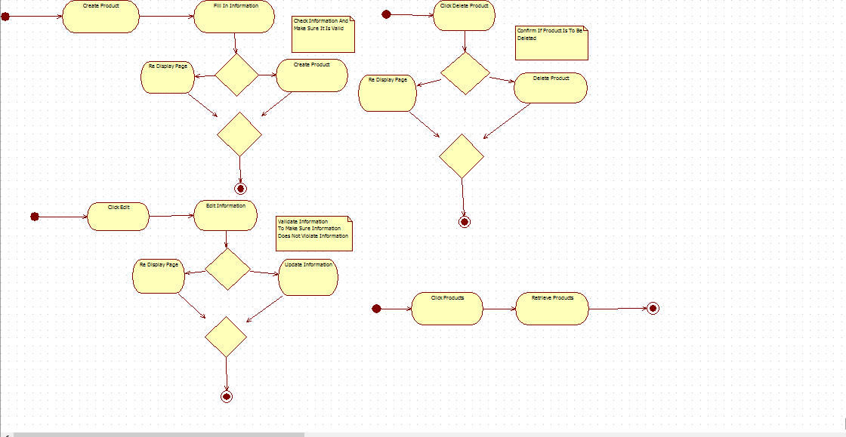

### Category based components

### Create Categories

**Use Case Name: Create Category**

**Author Name: Sajjad Patel, Soutrik Barua, Michael Voung**

**Applicable Business Rule:**

* Y.R Distribution: categories can only be created if certain products exists.

**Use Case Preconditions:**

Person that wants to make these changes must be signed in and must be a manager or an employee depending on the changes being made.

**Use Case Successful Post Conditions:**

* Category Must Be Created

**Main Flow:**

1)Employee/Manager Clicks on Categories

2)System retrieves all the categories

3)Employee/Manager Clicks Create Category

4)System Retrieves Create Page

1. Employee/Manager fills in information and clicks Create
2. System Creates Category

**Alternative Flows:**

1. Sign in wrong
   1. System opens password recovery page
   2. User types in email address
   3. System emails customer password
2. Invalid Information
   1. System redisplays page with red asterisk next to areas of invalid information
   2. User fills in correct information and clicks create
   3. System creates category

|  |  |  |
| --- | --- | --- |
| 1. **Scenario Name** | | **Scenario Description** |
| Main: Employee or manager creates a new category | | Employee or manager creates a new category |
| Alt: Incorrect log in to employee or manager account | Password recovery form is displayed. Employee successfully resets password. | |
| Alt: Invalid information | Invalid information provided for category, corrections are required before submission | |

B: Test Case Details

|  |  |  |  |  |
| --- | --- | --- | --- | --- |
| **Test Case** | **Scenario** | **Data Values/ Conditions being tested** | | **Expected Result** |
|  | Main: Employee or manager creates a new product | Either an employee or manager is currently signed in. | | System displays category creation form; confirmation prompt displayed; database updated with new category. |
|  | Alt: Employee or Manager inputs incorrect login information | Employee or manager forgets login information. | System displays password recovery form; Employee fills out form; system returns password reset form; Employee confirms and changes password. | |
|  | Alt: Invalid information | Employee or manager is currently signed in. | System displays category form; form with corrections required displayed; database updated with new category. | |

### Delete Categories

**Use Case Name: Delete Category**

**Author Name: Sajjad Patel, Soutrik, Michael**

**Applicable Business Rule:**

* Y.R Distribution: categories cannot be deleted if product using those categories exists.

**Use Case Preconditions:**

Person that wants to make these changes must be signed in and must be a manager or an employee depending on the changes being made.

**Use Case Successful Post Conditions:**

* Category must be deleted

**Main Flow:**

1)Employee/Manager Clicks on Categories

2)System retrieves all the Categories

3)Employee/Manager Clicks Delete Next to Category to be deleted

4)System Deletes Category

**Alternative Flows:**

1. Sign in wrong
   1. System opens password recovery page
   2. User types in email address
   3. System emails customer password

|  |  |  |
| --- | --- | --- |
| 1. **Scenario Name** | | **Scenario Description** |
| Main: Employee or manager deletes a category | | Employee or manager removes a category |
| Alt: Incorrect log in to employee or manager account | Password recovery form is displayed. Employee successfully resets password. | |

B: Test Case Details

|  |  |  |  |  |
| --- | --- | --- | --- | --- |
| **Test Case** | **Scenario** | **Data Values/ Conditions being tested** | | **Expected Result** |
|  | Main: Employee or manager updates product | Either an employee or manager is currently signed in. | | System displays categories; specific category information displayed; deletion prompt displayed; category deleted; database updated. |
|  | Alt: Employee or Manager inputs incorrect login information | Employee or manager forgets login information. | System displays password recovery form; Employee fills out form; system returns password reset form; Employee confirms and changes password. | |

### Retrieve Categories

**Use Case Name: Retrieve Category**

**Author Name: Sajjad Patel, Soutrik, Michael**

**Applicable Business Rule:**

* Y.R Distribution: categories can be retrieved if they existed before.

**Use Case Preconditions:**

Person that wants to make these changes must be signed in and must be a manager or an employee depending on the changes being made.

**Use Case Successful Post Conditions:**

* Categories are retrieved

**Main Flow:**

1)Employee/Manager Clicks on Categories

2)System retrieves all the categories

**Alternative Flows:**

1. Sign in wrong
   1. System opens password recovery page
   2. User types in email address
   3. System emails customer password

|  |  |  |
| --- | --- | --- |
| 1. **Scenario Name** | | **Scenario Description** |
| Main: Employee or manager retrieves categories | | Employee or manager retrieves a list of categories |
| Alt: Incorrect log in to employee or manager account | Password recovery form is displayed. Employee successfully resets password. | |

B: Test Case Details

|  |  |  |  |  |
| --- | --- | --- | --- | --- |
| **Test Case** | **Scenario** | **Data Values/ Conditions being tested** | | **Expected Result** |
|  | Main: Employee or manager updates product | Either an employee or manager is currently signed in. | | System displays category list. |
|  | Alt: Employee or Manager inputs incorrect login information | Employee or manager forgets login information. | System displays password recovery form; Employee fills out form; system returns password reset form; Employee confirms and changes password. | |

### Update Categories

**Use Case Name: Update Category**

**Author Name: Sajjad Patel, Soutrik, Michael**

**Applicable Business Rule:**

* Y.R Distribution: categories can be updated if already existed.

**Use Case Preconditions:**

Person that wants to make these changes must be signed in and must be a manager or an employee depending on the changes being made.

**Use Case Successful Post Conditions:**

* Category is updated

**Main Flow:**

1)Employee/Manager Clicks on Categories

2)System retrieves all the Categories

3)Employee/Manager Clicks edit Next to category to be edited

4)System retrieved edit page

5)Employee/Manager fills information to be changed

6)System updated category

**Alternative Flows:**

1. Sign in wrong
   1. System opens password recovery page
   2. User types in email address
   3. System emails customer password
2. Invalid information
   1. System retrieves page and displays it back to user with red asterisk next to fields to be fixed
   2. User fixes information and submits correct information
   3. System updates category

|  |  |  |
| --- | --- | --- |
| 1. **Scenario Name** | | **Scenario Description** |
| Main: Employee or manager updates categories | | Employee or manager updates one or more categories |
| Alt: Incorrect log in to employee or manager account | Password recovery form is displayed. Employee successfully resets password. | |
| Alt: Invalid information | Invalid information provided for category, corrections are required before submission | |

B: Test Case Details

|  |  |  |  |  |
| --- | --- | --- | --- | --- |
| **Test Case** | **Scenario** | **Data Values/ Conditions being tested** | | **Expected Result** |
|  | Main: Employee or manager updates category | Either an employee or manager is currently signed in. | | System displays category list; specific category information displayed; update category form displayed; database updated with new category information. |
|  | Alt: Employee or Manager inputs incorrect login information | Employee or manager forgets login information. | System displays password recovery form; Employee fills out form; system returns password reset form; Employee confirms and changes password. | |
|  | Alt: Invalid information | Employee or manager is currently signed in. | System displays update form; form with corrections required displayed; database updated with new updated category information. | |

ACTIVITY DIAGRAM

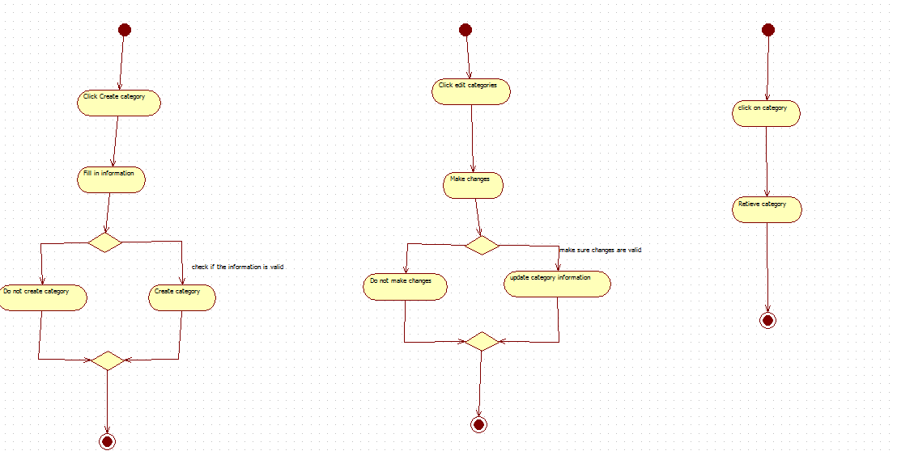

*************************************************************************************

### Promotion Based Component

* Create Promotions

**Use Case Name : Create Promotions**

**Author Name : Sajjad Patel, Soutrik Baura, Michael Vuong**

**Applicable Business Rules :**

- Y.R Distribution : Wants to create promotion

**Use case Preconditions :**

Person that wants to make the promotions must be signed in and this option is only available to the CEO

**Use Case Successful Post Conditions**

- CEO creates his or her desired promotion

**Main Flow**

1. CEO Clicks promotions
2. System displays options for promotion types or custom promotions available
3. CEO clicks create promotion
4. System retrieves create page
5. CEO fills in information for promotion and clicks create
6. System creates promotion

**Alternative Flows:**

1. Sign in wrong
   1. System opens password recovery page
   2. User types in email address
   3. System emails customer password
2. Invalid Information
   1. System redisplays page with red asterisk next to areas of invalid information
   2. User fills in correct information and clicks create
   3. System creates category

|  |  |  |
| --- | --- | --- |
| 1. **Scenario Name** | | **Scenario Description** |
| Main: CEO creates a promotion | | CEO creates one or more promotions |
| Alt: Incorrect log in to employee or manager account | Password recovery form is displayed. Employee successfully resets password. | |
| Alt: Invalid information | Invalid information provided for promotion, corrections are required before submission | |

B: Test Case Details

|  |  |  |  |  |
| --- | --- | --- | --- | --- |
| **Test Case** | **Scenario** | **Data Values/ Conditions being tested** | | **Expected Result** |
|  | Main: CEO updates product | CEO must be signed in | | System displays new promotion form; confirmation prompt displayed; database updated with new promotion. |
|  | Alt: Employee or Manager inputs incorrect login information | Employee or manager forgets login information. | System displays password recovery form; Employee fills out form; system returns password reset form; Employee confirms and changes password. | |
|  | Alt: Invalid information | CEO is signed in | System displays new promotion form; form with corrections required displayed; database updated with new promotion. | |

### Update Promotion

**Use Case Name : Update Promotions**

**Author Name : Sajjad Patel, Soutrik Baura, Michael Vuong**

**Applicable Business Rules :**

- Y.R Distribution : Wants to update an existing promotion

**Use case Preconditions :**

Person that wants to make the promotions must be signed in and this option is only available to the CEO.

Promotion must have been created previously by the CEO.

**Use Case Successful Post Conditions**

- CEO updates his or her desired promotion

**Main Flow**

1. CEO Clicks promotions
2. System displays options for promotion types or custom promotions available
3. CEO clicks update promotion
4. System retrieves page of current available promotions
5. CEO fills in information for promotion and clicks update
6. System updates promotion

**Alternative Flows:**

1. Sign in wrong
   1. System opens password recovery page
   2. User types in email address
   3. System emails customer password
2. Invalid Information
   1. System redisplays page with red asterisk next to areas of invalid information
   2. User fills in correct information and clicks create
   3. System creates category
3. Promotion does not exist
   1. System displays error and redirects to create promotion page
   2. User fills in information for creating a promotion
   3. System creates new promotion

|  |  |  |
| --- | --- | --- |
| 1. **Scenario Name** | | **Scenario Description** |
| Main: Employee or manager updates a promotion | | Employee or manager updates one or more promotions |
| Alt: Incorrect log in to employee or manager account | Password recovery form is displayed. Employee successfully resets password. | |
| Alt: Invalid information | Invalid information provided for promotion, corrections are required before submission | |
| Alt: Promotion does not exist | Promotion does not exist, the promotion cannot be updated unless the CEO creates the promotion | |

B: Test Case Details

|  |  |  |  |  |
| --- | --- | --- | --- | --- |
| **Test Case** | **Scenario** | **Data Values/ Conditions being tested** | | **Expected Result** |
|  | Main: Employee or manager updates promotion | Either an employee or manager is currently signed in. | | System displays promotion list; specific promotion displayed; update form displayed; confirmation prompt displayed; database is updated with updated promotion. |
|  | Alt: Employee or Manager inputs incorrect login information | Employee or manager forgets login information. | System displays password recovery form; Employee fills out form; system returns password reset form; Employee confirms and changes password. | |
|  | Alt: Invalid information | Employee or manager is currently signed in. | System displays update form; form with corrections required displayed; database updated with new updated promotion information. | |
|  | Alt: Promotion does not exist | CEO must be signed in | Error message: “ Promotion does not exist”; new promotion form displayed; confirmation prompt displayed; database updated with new promotion | |

### Delete Promotion

**Use Case Name : Delete Promotions**

**Author Name : Sajjad Patel, Soutrik Baura, Michael Vuong**

**Applicable Business Rules :**

- Y.R Distribution : Wants to Delete an existing promotion

**Use case Preconditions :**

Person that wants to make the promotions must be signed in and this option is only available to the CEO

**Use Case Successful Post Conditions**

- CEO removes his or her desired promotion

**Main Flow**

1. CEO Clicks promotions
2. System displays options for promotion types or custom promotions available
3. CEO clicks delete promotion
4. System retrieves current promotions page
5. CEO chooses from the list on which promotion to remove
6. System returns a confirmation request for the deletion request
7. CEO chooses confirm deletion
8. System removes promotion from system

**Alternative Flows:**

1. Sign in wrong
   1. System opens password recovery page
   2. User types in email address
   3. System emails customer password
2. Invalid Information
   1. System redisplays page with red asterisk next to areas of invalid information
   2. User fills in correct information and clicks create
   3. System creates category

|  |  |  |
| --- | --- | --- |
| 1. **Scenario Name** | | **Scenario Description** |
| Main: CEO removes a promotion | | CEO removes a promotion |
| Alt: Incorrect log in to employee or manager account | Password recovery form is displayed. Employee successfully resets password. | |

B: Test Case Details

|  |  |  |  |  |
| --- | --- | --- | --- | --- |
| **Test Case** | **Scenario** | **Data Values/ Conditions being tested** | | **Expected Result** |
|  | Main: CEO removes a promotion | CEO is currently signed in | | System displays promotion list; specific promotion displayed; deletion confirmation displayed; database updated with removed promotion. |
|  | Alt: Employee or Manager inputs incorrect login information | Employee or manager forgets login information. | System displays password recovery form; Employee fills out form; system returns password reset form; Employee confirms and changes password. | |

### Retrieve Promotion

**Use Case Name : Retrieve Promotions**

**Author Name : Sajjad Patel, Soutrik Baura, Michael Vuong**

**Applicable Business Rules :**

- Y.R Distribution : Wants to display a list of current promotions

**Use case Preconditions :**

Person that wants to view the promotions must be signed in and this option is only available to the CEO

**Use Case Successful Post Conditions**

- CEO views his or her desired promotion

**Main Flow**

1. CEO Clicks promotions
2. System displays options for promotion types or custom promotions available
3. CEO clicks view all current promotion
4. System retrieves current promotion page
5. CEO confirms and validates that every promotion is correct

**Alternative Flows:**

1. Sign in wrong
   1. System opens password recovery page
   2. User types in email address
   3. System emails customer password
2. Invalid Information
   1. System redisplays page with red asterisk next to areas of invalid information
   2. User fills in correct information and clicks create
   3. System creates category
3. No Promotions Are Currently Active
   1. Systems displays that there are no promotions that are available
   2. CEO clicks create promotion
   3. System displays create promotion page
   4. CEO fills in promotion information
   5. System creates promotion

|  |  |  |
| --- | --- | --- |
| 1. **Scenario Name** | | **Scenario Description** |
| Main: Employee or manager updates products | | Employee or manager updates one or more products |
| Alt: Incorrect log in to employee or manager account | Password recovery form is displayed. Employee successfully resets password. | |
| Alt: No promotions are currently active | No promotions active, promotion must be created | |

B: Test Case Details

|  |  |  |  |  |
| --- | --- | --- | --- | --- |
| **Test Case** | **Scenario** | **Data Values/ Conditions being tested** | | **Expected Result** |
|  | Main: CEO sees a list of all current promotions | CEO is currently signed in. | | System displays promotion list; specific promotion information displayed; |
|  | Alt: Employee or Manager inputs incorrect login information | Employee or manager forgets login information. | System displays password recovery form; Employee fills out form; system returns password reset form; Employee confirms and changes password. | |
|  | Alt: No promotions are currently active | CEO must be currently signed in | Error message: “No promotions are currently active”; new promotion form displayed; confirmation prompt displayed; database updated with new promotion. | |

ACTIVITY DIAGRAMS

